**Title:**

Hand gesture Control system.

**Abstract:**

Hand gesture control system is getting a great attention as it provides ability to interact with machine efficiently using human computer interaction. As we cannot perform so many operation using this interface as it needs a lot of CPU and GPU processing. So, for now we will understand the way and methods to achieve the target.

**Introduction:**

The main aim of building hand gesture control system is to create a natural interaction between human and computer. Where the recognized hand gesture will instruct machine to perform action instructed as per instruction. Defining human computer interaction is a term used to refer the relation between human and machine. It is also termed as Man-Machine interaction. We have to define two main things while designing that are functionality and usability. System functionality refer to set of function and services that system provides and usability refer to level and scope that system equips to user.

**Methodology:**

We have several methods for acquiring necessary information for performing different task. Some methods used additional hardware devices such as data gloves devices and color makers to easily extract comprehensive description of features. Other method based on appearance of the hand using segments to extract features for controlling system.

Few usable methods used are given below-

1. **Segmentation**- first process for recognizing hand gestures. It is process of dividing the input image into regions separated by boundaries. If input is a dynamic gesture so we have to track and locate the hand but if it is static so we only need to segment it. As we will be using the dynamic gesture so we have to divide the video into frames and each frame has to be processed alone and we are using track information that is rectangle and tools like Kalman filter etc.
2. **Feature extraction**- for extracting features we have used points on fingers and along with few points on palms that will provide us in total 21 points (fig 1).

For this purpose, we can also used a google library MediaPipe used for designing pipelining for processing perceptual data from different modalities such as videos or audio.

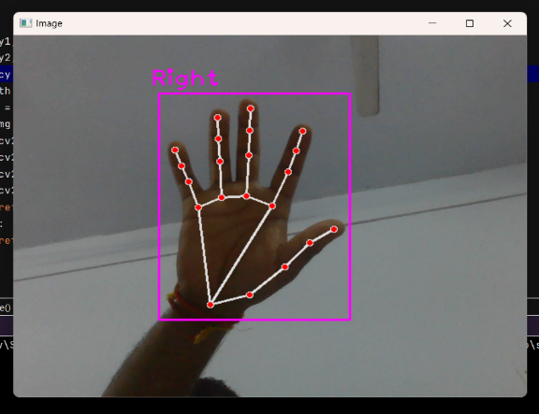

fig1

1. **Gesture classification** – After modeling and analysis of the input hand image gesture classification is used to work with for this, we have used the points of fingertips to perform the operation and the gestures for our system is difference between these fingertip points.

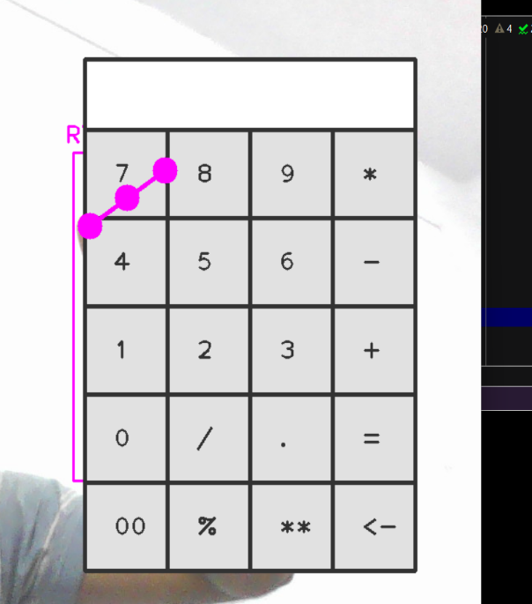 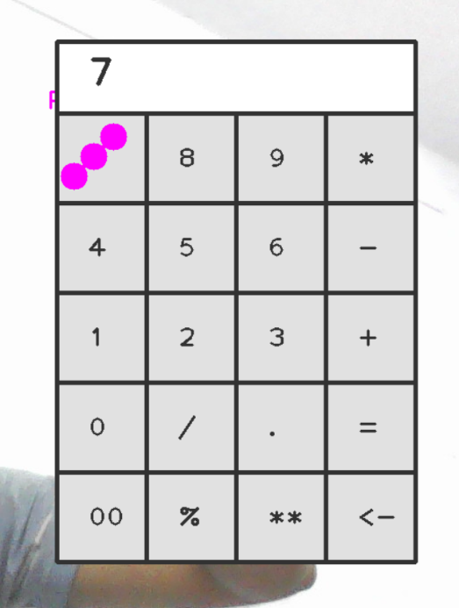

fig2 fig3

**Results:**

As a first step we try the hand detection based on available database of OpenCV. Then capturing live hands of camera, the initialization has been done. Then we locate the points on hands. Which can be used for further activities.

**Conclusion:**

The main aim of project is to develop real time calculation system. This paper explain method, steps and all details needed to make a virtual calculator and its working.